**HTML & CSS 101: Introduction to HTML**

1. **Introduction to HTML**

HTML – Serves as the backbone of the web content. It utilizes tags to define various components like links, paragraphs, headings and images. Its documents consist of a hierarchical structure, with standard layout including the head and the body sections.

CSS – Is a programming language used in web development to define the visual presentation of HTML documents. It allows developers to control the layout, colors, fonts, and other designs of the webpage.

JAVASRIPT – Is a versatile programming language used for web development. It enables the creation of dynamic and interactive elements on websites.

1. **HTML Text Formatting**

HTML Syntax - HTML is a language used to structure web pages. It uses tags, which are enclosed in less-than and greater-than symbols, to mark different elements. Tags come in two types: opening tags and closing tags.

* HTML element components - These tags work together to define elements, which are like packages containing content. e.g. Paragraphs

<p> This is a paragraph </p>

* Nested HTML element – A short paragraph that uses emphasized text for effect. The paragraph itself is wrapped in opening and closing p tags.

<p> This a paragraph with <em>emphasised text</em> for effect </p>

* Nested HTML with Article – Example

<Article>

<h> Headline </h>

<p> First paragraph </p>

<p> Second paragraph </p>

<p> Third paragraph with <em> emphasised text </em> for effect </p>

</Article>

* Using Bold Elements - <strong> This adds meaning to the text. e.g. header / article.

<b> Simply allows us to make something bold visually and < does not imply any meaning.

* HTML Bold and italic - There are four HTML elements related to this, two for bold and two for italic.

Bold – (bold and strong)

Italic – (italic and emphasised / nested)

Italic elements example:

<p>My <em>favourite</em> character from <i>Sesame</i> is Moshe. </p>

* HTML Lists
* Unordered list – The term or key is enclosed in a <ul>
* Ordered list – The term or key is enclosed in a <ol>
* Definition list – The term or key is enclosed in a <dl>. List is used when we want to create a list of resembles a key value pair in a computer science listed of just items have terms and their corresponding description.
* HTML Quotes

- To attribute the quote, we can use the <cite>

- And distinguish a quote from the surrounding text we can wrap the whole thing in a <blockquote>. e.g.

<backquote>

<p> paragraph </p>

<cite>- Jeremy </cite>

</backquote>

* Using time elements

Datetime attributes

<time datetime=’’ 2015-05-08”>May 8, 2015</time> (date attributes)

<time datetime=” 20:00”, 20:00 </>time (time attributes)

<time datetime=” PT2H30M”, 2h 30m </time>

<time datetime=” 14:15:28.5”, 14:15: 28.5 </time>

* HTML Code, pre and br
* Using code element

We can customize this to match our desired look. By default, code is treated as an

inline element, meaning it remains part of the sentence it's in.

Example:

<p>

We can write <code> {color: green;} </code>

In our CSS, and it will apply to any thin marked up as an <code>&lt, H4&gt;</code> elements.

</p>

* Using br element

<p>

They<br>

Say you took my manhood, <br>

Mama. <br>

Come sit on my lap<br>

And tell me<br>

What do you want me to say<br>

To them, just<br>

Before I annihilate<br>

Their ignorance?

</p>

* Using pre element

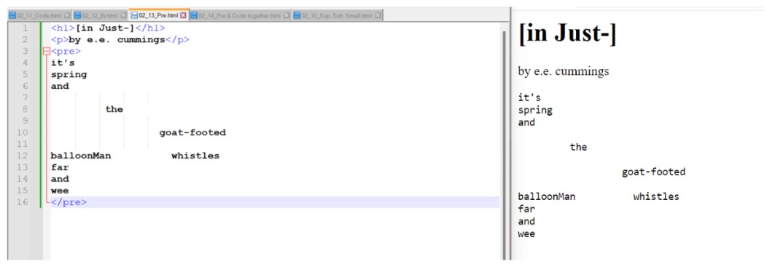

* Using pre and code together

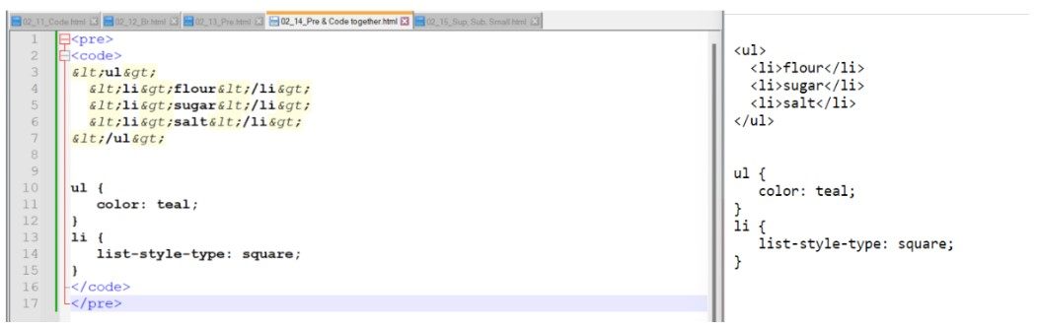

* HTML Superscript, Subscripts and small

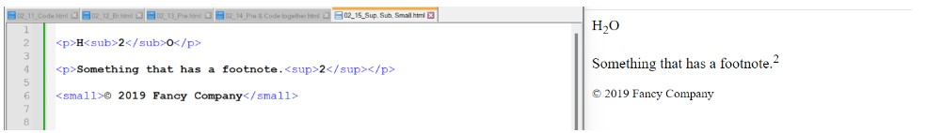

1. **HTML Capabilities**

Troubleshooting and Debugging HTML Code – Are Browser developer tools that can help identify errors.

* HTML debugging code – to debug HTML code, use your browser’s developer tools. Right click on the webpage, select” inspect” and navigate to the “Console” tab. Look for error messages and use them to identify and fix issues in your HTML code.
* Using Browser DevTools Inspector
* Right-Click and inspect: Right click on an element on the webpage and select “Inspect Element.” THIS OPENS THE DEVELOPER TOOLS.
* Elements Tabs: In the “Elements” tab, you can see the HTML structure. Hover over elements to highlight them on the webpage.
* Console tab: Navigate to the “Console” tab to check for error messages. Any syntax errors or issues will be logged here.
* Styles tab: Explore the “Styles” tab to inspect and modify CSS styles applied to elements.
* Network Tab (if relevant): Use the network tab to monitor network requests and check for any failed requests or issues.
* Sources Tab (for JavaScript): If your HTML includes JavaScript, check the “sources” tab for debugging JavaScript code.
* Audit tab (optional): The “Audit” Tab can help identify the performance and accessibility issues.
* Reviewing broken code
* Well, open the developer tools by right-clicking and take a closer look. It turns out the browser is doing some fixing to the HTML it received while building the DOM tree. It believes there should be five items: one, two, empty, three, four. The browser is adding an extra set of tags.
* Return to the original HTML code, and before the third item, the mistake occurred. Instead of ending the previous list item, we mistakenly started a new one. Correct this by adding the missing slash. This will fix the DOM. Whenever you are unsure about what is happening, just turn to the developer tools in your browser to figure things out.

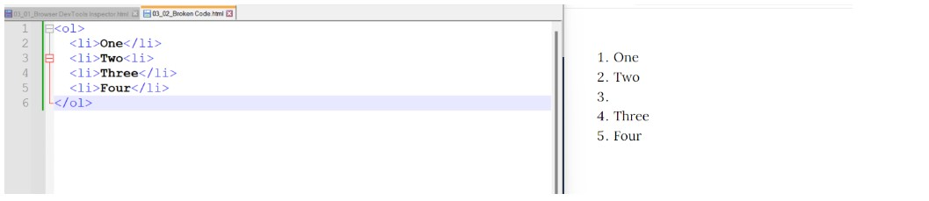

* HTML Attributes

Using global attributes

* The class attributes <p class=” intro”> This is the introduction </p>
* The id attribute <p class=” intro” id=” article-intro”> This is the introduction. </p>

Class and id attributes

<h1> class="page-tittle"> Bees </h1>

<section id="tac"

<h3 class="tac-tittle"> Table of Contents </h3>

<ol>

<li><a href="Beekeeping"> Beekeeping </a></li>

<li><a href="In art and literature"> In art and literature </a></li>

<li><a href="Thought of Bees"> Thought of Bees </a></li>

<li><a href="Kinds of Bees" Kinds of Bees </a></li>

</ol>

</section>

* IRIA Roles

ARIA Roles are like extra attributes that we can add to HTML elements to make them more meaningful and help browsers understand what they represent. The goal is to rely on proper HTML elements to convey the right message about the content's meaning, without needing ARIA Roles. However, reality does not always align with ideals, and sometimes compromises must be made in the code

ARIA Roles come into play when we want to provide essential information to assistive technologies like screen readers, braille displays, and magnifiers to ensure a website is fully accessible. ARIA came about when the web began replacing native applications, and it is particularly valuable for ensuring that everyone can use the full functionality of a complex interface in an app.

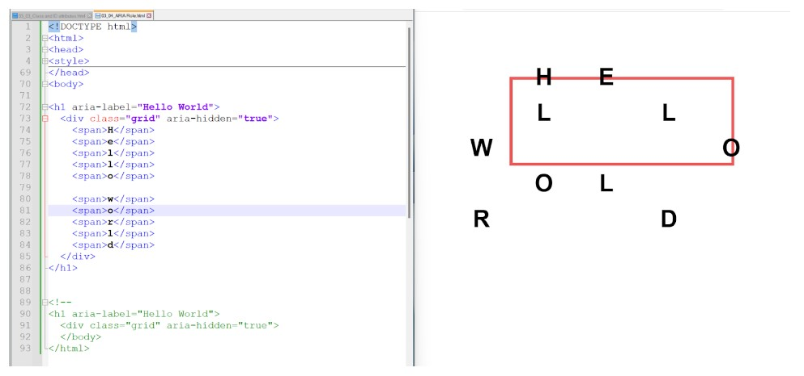

* Formatting HTML

If you use elements like <pre>, <code>, or <textarea>, or if you modify the whitespace handling with CSS, then extra spaces and indentations can matter. Usually, the browser does not really care about anything more than a single space.

* + WORKING WITH EXTRA SPACES IN HTML

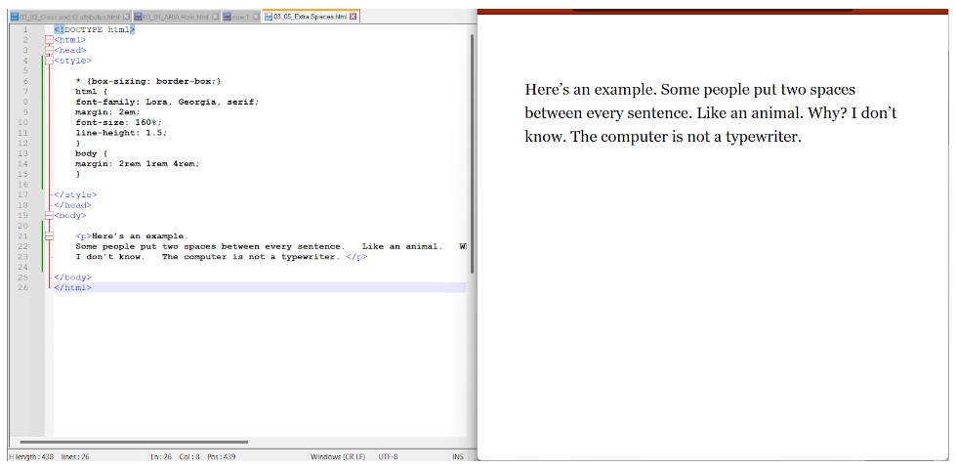

- Working with comments in HTML

According to programmers, they enhance code readability by adding comments that explain its purpose. In HTML, comments are inserted by typing "<!--" at the start and "-->" at the end. These comments are disregarded by the browser. This feature helps us quickly identify when code is commented out and prevents any confusion when it does not function as expected.

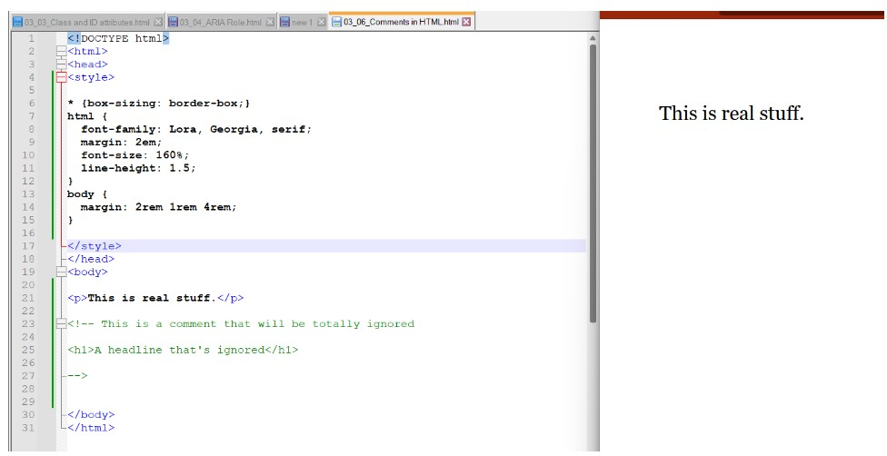

-Working with upper case and lower case

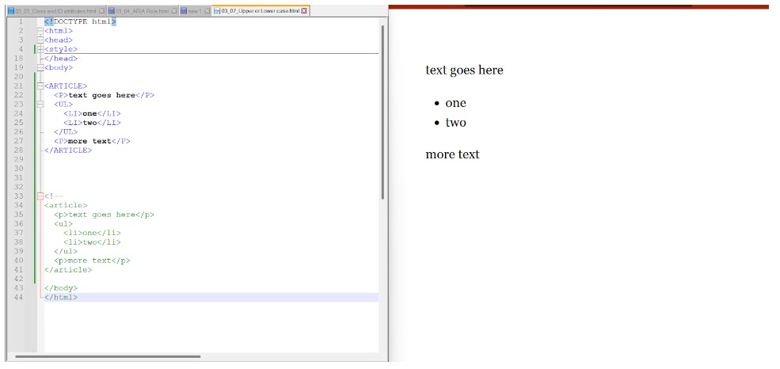

- Working with long and short elements in HTML

some HTML elements are very short, like <p> or <i>, while others are longer, such as <article> or <video>

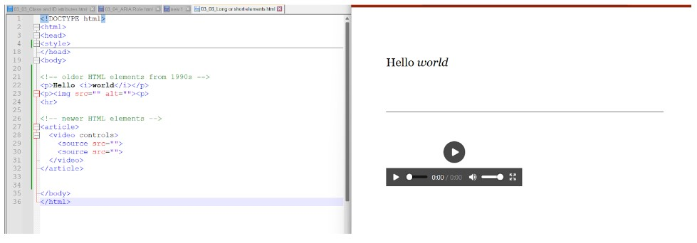

- Working with self-closing elements in HTM

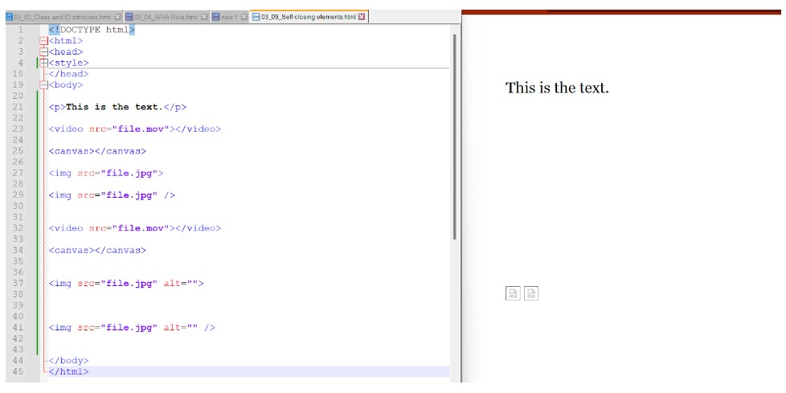

* Unusual Characters

4.**HTML Navigation and Linking**

We encounter links everywhere we go online — navigation bars, menus packed with options, enticing teaser cards, and pages full of clickable article titles. It has become the norm.

* Working with links

When creating links as developers or content creators, we need to include them ourselves. This protocol was one of the most significant inventions when the web was created. This is how links are made using absolute URLs.

* HTML URL Pathways

When linking to something within the same site and domain as the page containing the link, a relative URL can be used instead.

* Creating URLs from scratch

To form a URL from scratch, you first need to grasp how files are organized. Imagine that there are a bunch of files neatly arranged into different directories or folders. If we want to link to a blog post from March 9th, instruct the browser to look inside the folder called "blog" and locate the folder named "March-9.html". Now, filenames come with extensions like .html, .jpg, .css, .js, whereas folder names simply have names like "blog" or "people" without any extension. The slashes in a URL indicate that we should look deeper into the file structure or go one level down.

To create a relative URL, omit the domain name but include the initial slash at the beginning. This tells the browser to start from the root level of the file structure, which is the outermost top level. Alternatively, we can write the path to be relative to the file where the link is written.

* Creating local URLs

We have two options to write the URL:

1. /images/logo.gif

2./images/logo.gif

The first version, /images/logo.gif, creates a URL that is relative to the root level. It means the browser will start looking for the file from the root of the website. On the other hand, the second version, ../images/logo.gif, creates a URL that is relative to the location of the file where the URL is written. The ".." followed by a slash means going up one level in the directory structure.

So, the URL ../images/logo.gif means starting from the current location, go up one level, find the folder named images, and then look inside it for the file logo.gif.

* Navigation

Now that links and the structure URLs have been covered, let's explore common ways to make menus or navigation bars. Imagine we want to make a main menu bar for our website. We have four links: home, people, prices, and contact.

- Main Navigation

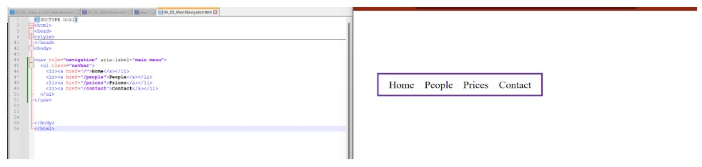

- Breadcrumbs

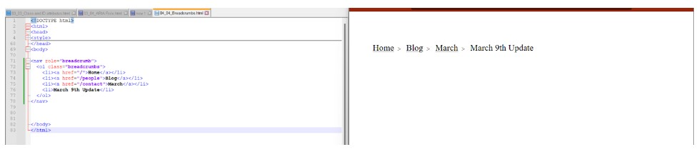

- Footerlinks

